High Level Design (HLD)

**Bird Strikes Analysis**

**Onkar Arjunwade**

Contents

Abstract 3

1. Introduction 4
   1. Why this High-Level Design Document? 4
   2. Scope 4
2. General Description 5
   1. Product Perspective & Problem Statement 5
   2. Tools used 5
3. Design Details 6
   1. Functional Architecture 6
   2. Optimization 7
4. KPI 8
   1. KPI (Key Performance Indicators) 8
5. Deployment 8

# Abstract

A bird strike is strictly defined as a collision between a bird and an aircraft which is in flight or on a take-off or landing roll. The term is often expanded to cover other wildlife strikes - with bats or ground animals. Bird Strike is common and can be a significant threat to aircraft safety. For smaller aircraft, significant damage may be caused to the aircraft structure and all aircraft, especially jet-engine ones, are vulnerable to the loss of thrust which can follow the ingestion of birds into engine air intakes. This has resulted in several fatal accidents. Bird strikes may occur during any phase of flight, but are most likely during the take-off, initial climb, approach and landing phases due to the greater numbers of birds in flight at lower levels. To have a closer look the following document visually depicts the data collected on Bird Strikes by FAA between 2000-2011.

# Introduction

## Why this High-Level Design Document?

The purpose of this High-Level Design (HLD) Document is to add the necessary detail to the current project description to represent a suitable model for coding. This document is also intended to help detect contradictions prior to coding, and can be used as a reference manual for how the modules interact at a high level.

The HLD will:

* + - Present all of the design aspects and define them in detail
    - Describe the user interface being implemented
    - Describe the hardware and software interfaces
    - Describe the performance requirements
    - Include design features and the architecture of the project
    - List and describe the non-functional attributes like:
      * Security
      * Reliability
      * Maintainability
      * Portability
      * Reusability
      * Application compatibility
      * Resource utilization
      * Serviceability

## Scope

The HLD documentation presents the structure of the system, such as the database architecture, application architecture (layers), application flow (Navigation), and technology architecture. The HLD uses non-technical to mildly-technical terms which should be understandable to the administrators of the system.

# General Description

## Product Perspective & Problem Statement

The goal of this project is to analyze the bird strike incidents happened between 2000- 2011. To achieve the goal, we used a data set that is collected by FAA during 2000-2011. The objective of the project is to perform data visualization techniques to understand insights of the data. This project aims apply various Business Intelligence tools such as Tableau or Power BI to get a visual understanding of the data.

## Tools used

Business Intelligence tools and libraries works such as MS-Excel, MS Power BI, Jupyter Notebook and Python Programming Language are used to build the whole framework.

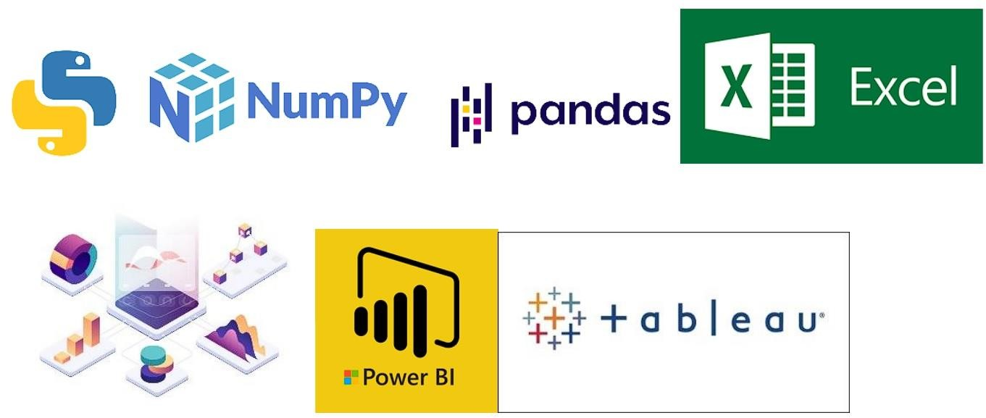

# Design Details

## Functional Architecture

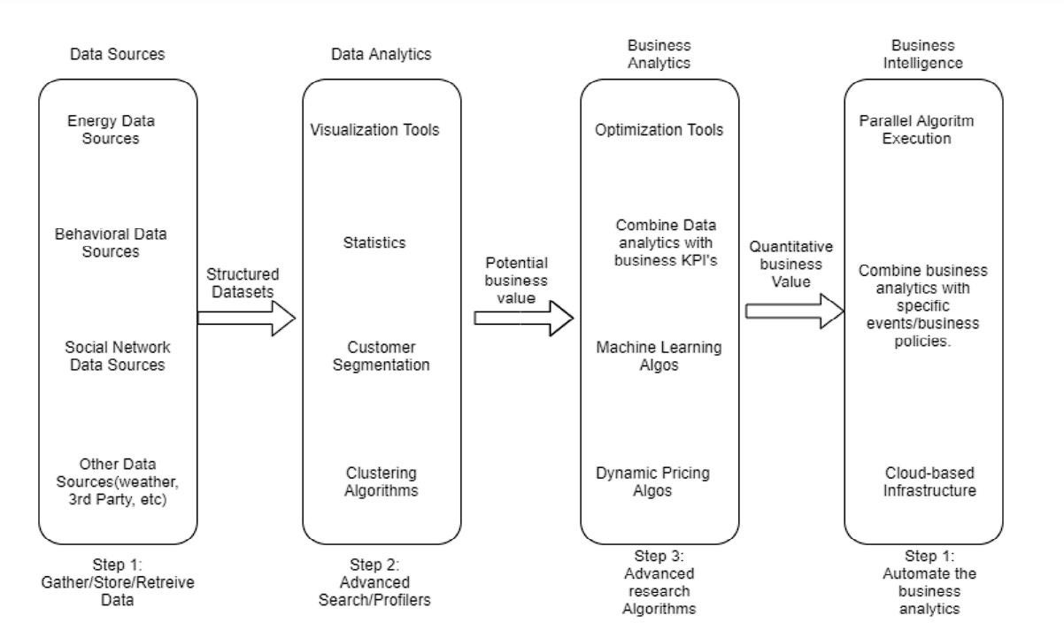

Structured

datasets

*Figure 1 Functional Architecture of Business Intelligence*

How BI Really Works

* Data warehousing
* ERP
* Knowledge repository
* CMS
* DMS

Organizational Memory

* Business analytics tool
* Data mining
* Real-time Decision

Information Integration

* Text mining tools
* Web mining tools
* Environmental scanning
* RFID

Insight Creation

* OLAP tools
* Visualization tools
* Digital Dashboards
* Score Card

Presentation

## Optimization

### Your data strategy drives performance

* + Minimize the number of fields
  + Minimize the number of records
  + Optimize extracts to speed up future queries by materializing calculations, removing columns and the use of accelerated views

### Reduce the marks (data points) in your view

* + Practice guided analytics. There’s no need to fit everything you plan to show in a single view. Compile related views and connect them with action filters to travel from overview to highly- granular views at the speed of thought.
  + Remove unneeded dimensions from the detail shelf.
  + Explore. Try displaying your data in different types of views.

### Limit your filters by number and type

* + Reduce the number of filters in use. Excessive filters on a view will create a more complex query, which takes longer to return results. Double-check your filters and remove any that aren’t necessary.
  + Use an include filter. Exclude filters load the entire domain of a dimension while including filters do not. An include filter runs much faster than an exclude filter, especially for dimensions with many members.
  + Use a continuous date filter. Continuous date filters (relative and range-of date filters) can take advantage of the indexing properties in your database and are faster than discrete data filters.
  + Use Boolean or numeric filters. Computers process integers and Booleans (t/f) much faster than strings.
  + Use parameters and action filters. These reduce the query load (and work across data sources).

### Optimize and materialize your calculations

* + Perform calculations in the database
  + Reduce the number of nested calculations.
  + Reduce the granularity of LOD or table calculations in the view. The more granular the calculation, the longer it takes.
    - LODs - Look at the number of unique dimension members in the calculation.



* + - Table Calculations - the more marks in the view, the longer it will take to calculate.
  + Where possible, use MIN or MAX instead of AVG. AVG requires more processing than MIN or MAX. Often rows will be duplicated and display the same result with MIN, MAX, or AVG.
  + Make groups with calculations. Like include filters, calculated groups load only named members of the domain, whereas Tableau’s group function loads the entire domain.
  + Use Booleans or numeric calculations instead of string calculations. Computers can process integers and Booleans (t/f) much faster than strings. Boolean>Int>Float>Date>DateTime>String.

# KPI

Dashboards will be implemented to display and indicate certain KPIs and relevant indicators for the bird strike incidents. As and when the system starts to capture the historical/periodic data for a user, the dashboards will be included to display charts over time with progress on various indicators or factors



## KPI (Key Performance Indicators)

Key indicators displaying a summary of the Bird Strike incidents and its relationship with different metrics

1. Total number of bird strike incidents from 2000-2011
2. Total cost incurred due to such incidents
3. Total number of people injured during the incidents
4. Impact of warning the pilot on bird strikes
5. Influence of weather conditions on bird strikes
6. Impact of aircraft size
7. Seasonal patterns
8. Influence of altitude at the time of strike
9. Influence of geographical location

# Deployment

Prioritizing data and analytics couldn’t come at a better time. Your company, no matter what size, is already collecting data and most likely analyzing just a portion of it to solve business problems, gain competitive advantages, and drive enterprise transformation. With the explosive growth of enterprise data, database technologies, and the high demand for analytical skills, today’s most effective IT organizations have shifted their focus to enabling self-service by deploying and operating Power BI at scale, as well as organizing, orchestrating, and unifying disparate sources of data for business users and experts alike to author and consume content. Power BI prioritizes choice in flexibility to fit, rather than dictate, your enterprise architecture. Power BI Desktop and Power BI Service leverage your existing technology investments and integrate them into your IT infrastructure to provide a self-service, modern analytics platform for your users. With on-premises, cloud, and hosted options, there is a version of Power BI to match your requirements.

